**DECIMAL TO OCTAL CONVERSION**

**EXP NO: 29**

**AIM:** To write a C program to implement decimal to octal conversion.

**ALGORITHM:**

1)  Store the remainder when the number is divided by 8 in an array.

2)      Divide the number by 8 now.

3)      Repeat the above two steps until the number is not equal to 0.

4)      Print the array in reverse order now.

**PROGRAM:**  
  
  
#include

< stdio.h >  
  
  
int main()  
  
  
{  
  
  
    long decimal, remainder, quotient, octal=0;  
  
  
    int octal num[100], i = 1, j;  
  
  
    print f("Enter the decimal number:");  
  
  
    scan f("%d", &decimal);  
  
  
    quotient = decimal;  
  
  
    while (quotient != 0)  
  
  
    {  
  
  
        octal num[i++] = quotient % 8;  
  
  
        quotient = quotient / 8;  
  
  
    }  
  
  
    for (j = i - 1; j > 0; j--)  
  
  
        octal= octal*10 + octal num[j];  
  
  
    print f("Equivalent octal value of decimal no %d is: %d  ",decimal, octal num);  
  
  
    return 0;  
}  
  
**INPUT:**

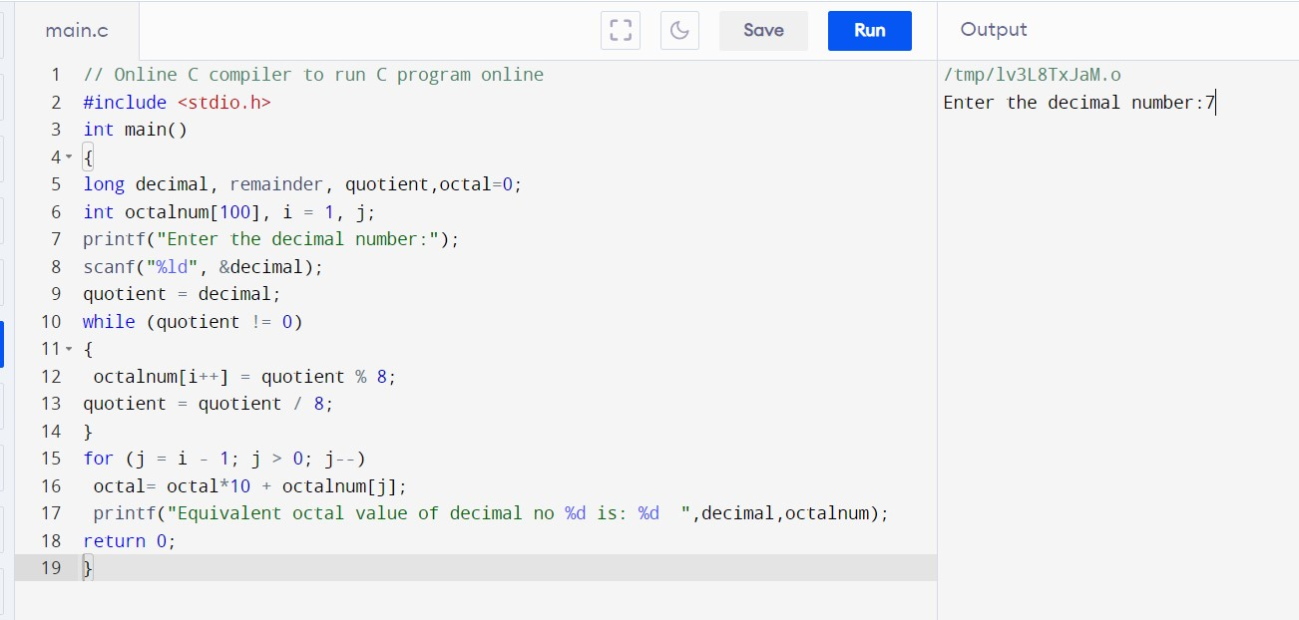  
  
  
  
  
  
  
  
  
**OUTPUT:**

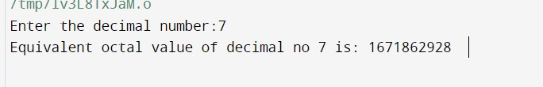  
  
  
  
**RESULT:**Thus the program was executed successfully using Dev C++.